**AQA Electricity Booklet 1 Name:**

**Q1.**

The current in a wire is 20 mA.

How many electrons pass a point in the wire in 2 minutes?

|  |  |  |
| --- | --- | --- |
| **A** | 2.5 × 1017 |  |
| **B** | 1.5 × 1019 |  |
| **C** | 2.5 × 1020 |  |
| **D** | 1.5 × 1022 |  |

**(Total 1 mark)**

**Q2.**

In each of the following circuits the battery has negligible internal resistance and the bulbs are identical.

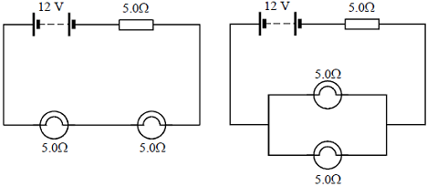

**Figure 1**                                                    **Figure 2**

(a)     For the circuit shown in **Figure 1** calculate

(i)      the current flowing through each bulb,

______________________________________________________________

______________________________________________________________

(ii)     the power dissipated in each bulb.

______________________________________________________________

______________________________________________________________

**(2)**

(b)     In the circuit shown in **Figure 2** calculate the current flowing through each bulb.

___________________________________________________________________

___________________________________________________________________

___________________________________________________________________

**(3)**

(c)     Explain how the brightness of the bulbs in **Figure 1** compares with the brightness of the bulbs in **Figure 2**.

___________________________________________________________________

___________________________________________________________________

**(2)**

**(Total 7 marks)**

**Q3.** (a)     A student is given three resistors of resistance 3.0 Ω, 4.0 Ω and 6.0 Ω respectively.

(i)      Draw the arrangement, using all three resistors, which will give the largest resistance.

(ii)     Calculate the resistance of the arrangement you have drawn.

______________________________________________________________

______________________________________________________________

(iii)     Draw the arrangement, using all three resistors, which will give the smallest resistance.

(iv)    Calculate the resistance of the arrangement you have drawn.

______________________________________________________________

______________________________________________________________

______________________________________________________________

**(5)**

(b)     The three resistors are now connected to a battery of emf 12 V and negligible internal resistance, as shown in **Figure 1**.

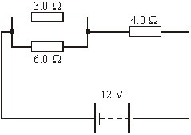

**Figure 1**

(i)      Calculate the total resistance in the circuit.

______________________________________________________________

______________________________________________________________

(ii)     Calculate the voltage across the 6.0 Ω resistor.

______________________________________________________________

______________________________________________________________

______________________________________________________________

**(4)**

**(Total 9 marks)**

**Q4.** Copper metal is a good conductor of electricity because copper atoms in copper metal

|  |  |
| --- | --- |
| **A** | have gained an extra or “free” electron |
| **B** | are ionised so that both ions and “free” electrons can move |
| **C** | have a negative charge because of the “free” electrons |
| **D** | have lost an electron to form positive ions and “free” electrons |

**(Total 1 mark)**

**Q5.**

(a)     A set of decorative lights consists of a string of lamps. Each lamp is rated at 5.0 V, 0.40 W and is connected in series to a 230 V supply.

Calculate

(i)      the number of lamps in the set, so that each lamp operates at the correct rating,

______________________________________________________________

______________________________________________________________

(ii)     the current in the circuit,

______________________________________________________________

______________________________________________________________

(iii)     the resistance of each lamp,

______________________________________________________________

______________________________________________________________

(iv)    the total electrical energy transferred by the set of lights in 2 hours.

______________________________________________________________

______________________________________________________________

______________________________________________________________

**(5)**

(b)     When assembled at the factory, one set of lights inadvertently contains 10 lamps too many. All are connected in series. Assume that the resistance of each lamp is the same as that calculated in part (a) (iii).

(i)      Calculate the current in this set of lights when connected to a 230 V supply.

______________________________________________________________

______________________________________________________________

______________________________________________________________

(ii)     How would the brightness of each lamp in this set compare with the brightness of each lamp in the correct set?

______________________________________________________________

**(3)**

**(Total 8 marks)**

**Q6.**

In a cathode ray tube 7.5 × 1015 electrons strike the screen in 40 s. What current does this represent?

Charge of the electron is 1.6 × 10–19 C.

|  |  |  |
| --- | --- | --- |
| **A** | 1.3 × 10–16 A |  |
| **B** | 5.3 × 10–15 A |  |
| **C** | 3.0 × 10–5 A |  |
| **D** | 1.2 × 10–3 A |  |

**(Total 1 mark)**

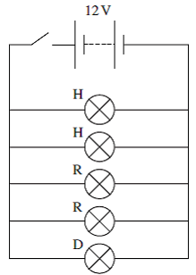**Q7.** The Figure below shows a simplified circuit for the main lights on a car. The battery has an emf of 12 V and no internal resistance.

The table below gives data about the lamps being used in the circuit. The resistances given are correct when the lamp is operating at its normal operating voltage.

|  |  |  |
| --- | --- | --- |
| **LAMP** | **OPERATING VOLTAGE V** | **RESISTANCE Ω** |
| H, headlight lamp | 12 | 3.8 |
| R, rear lamp | 12 | 5.6 |
| D, dashboard lamp | 12 | 72 |

(a)     (i)      Calculate the power of a single headlight lamp when operating at 12 V.

______________________________________________________________

______________________________________________________________

______________________________________________________________

______________________________________________________________

power ______________________ W

**(2)**

(ii)     Calculate the resistance of the combination of lamps when operating at 12 V.

______________________________________________________________

______________________________________________________________

______________________________________________________________

______________________________________________________________

resistance ______________________ Ω

**(3)**

(iii)     Calculate the total power of the combination of lamps when operating at 12 V.

______________________________________________________________

______________________________________________________________

______________________________________________________________

______________________________________________________________

power ______________________ W

**(2)**

(b)     The battery is replaced with one of a lower emf. State and explain how the resistance of the lamps would have to change in order to achieve the same brightness.

___________________________________________________________________

___________________________________________________________________

___________________________________________________________________

___________________________________________________________________

___________________________________________________________________

___________________________________________________________________

**(2)**

**(Total 9 marks)**

**Q8.** The circuit diagram below shows a battery of electromotive force (emf) 12 V and internal resistance 1.5 Ω connected to a 2.0 Ω resistor in parallel with an unknown resistor, R. The battery supplies a current of 4.2 A.

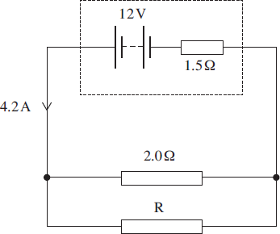

(a)     (i)      Show that the potential difference (pd) across the internal resistance is 6.3 V.

**(1)**

(ii)     Calculate the pd across the 2.0 Ω resistor.

pd ____________________V

**(1)**

(iii)    Calculate the current in the 2.0 Ω resistor.

current ____________________A

**(1)**

(iv)    Determine the current in R.

current ____________________ A

**(1)**

(v)     Calculate the resistance of R.

R ____________________ Ω

**(1)**

(vi)    Calculate the total resistance of the circuit.

circuit resistance ____________________ Ω

**(2)**

(b)     The battery converts chemical energy into electrical energy that is then dissipated in the internal resistance and the two external resistors.

(i)      Using appropriate data values that you have calculated, complete the following table by calculating the rate of energy dissipation in each resistor.

|  |  |
| --- | --- |
| **resistor** | **rate of energy dissipation / W** |
| internal resistance |  |
| 2.0 Ω |  |
| R |  |

**(3)**

(ii)     Hence show that energy is conserved in the circuit.

______________________________________________________________

______________________________________________________________

**(2)**

**(Total 12 marks)**

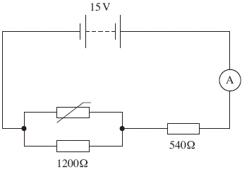**Q9.** The circuit shown below shows a thermistor connected in a circuit with two resistors, an ammeter and a battery of emf 15V and negligible internal resistance.

(a)     When the thermistor is at a certain temperature the current through the ammeter is 10.0 mA.

(i)      Calculate the pd across the 540 Ω resistor.

answer = ______________________ V

**(1)**

(ii)     Calculate the pd across the 1200 Ω resistor.

answer = ______________________ V

**(1)**

(iii)     Calculate the resistance of the parallel combination of the resistor and the thermistor.

answer = ______________________ Ω

**(2)**

(iv)    Calculate the resistance of the thermistor.

answer = ______________________ Ω

**(2)**

(b)     The temperature of the thermistor is increased so that its resistance decreases.  
State and explain what happens to the pd across the 1200 Ω resistor.

___________________________________________________________________

___________________________________________________________________

___________________________________________________________________

___________________________________________________________________

**(3)**

**(Total 9 marks)**

**Q10.** The circuit diagram below shows a 12 V battery of negligible internal resistance connected to a combination of three resistors and a thermistor.

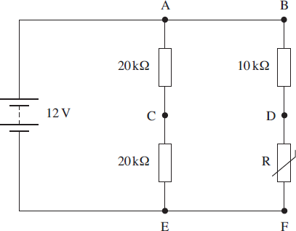

(a)     When the resistance of the thermistor is 5.0 kΩ

(i)      calculate the total resistance of the circuit,

total resistance = ____________________ kΩ

**(3)**

(ii)     calculate the current in the battery.

current = ____________________ mA

**(1)**

(b)     A high-resistance voltmeter is used to measure the potential difference (pd) between points A-C, D-F and C-D in turn.  
Complete the following table indicating the reading of the voltmeter at each of the three positions.

|  |  |
| --- | --- |
| **voltmeter position** | **pd / V** |
| A-C |  |
| D-F |  |
| C-D |  |

**(3)**

(c)     The thermistor is heated so that its resistance decreases. State and explain the effect this has on the voltmeter reading in the following positions.

(i)      A–C __________________________________________________________

______________________________________________________________

______________________________________________________________

______________________________________________________________

**(2)**

(ii)     D–F __________________________________________________________

______________________________________________________________

______________________________________________________________

______________________________________________________________

**(2)**

**(Total 11 marks)**

**Q11.**

A battery of negligible internal resistance is connected to lamp P in parallel with lamp Q as shown in **Figure 1**. The emf of the battery is 12 V.

**Figure 1**

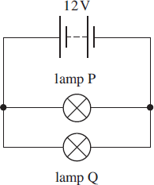

(a)     Lamp P is rated at 12 V 36 W and lamp Q is rated at 12 V 6 W.

(i)      Calculate the current in the battery.

answer = ____________________ A

**(2)**

(ii)     Calculate the resistance of P.

answer = ____________________ Ω

**(1)**

(iii)    Calculate the resistance of Q.

answer = ____________________ Ω

**(1)**

(b)     State and explain the effect on the brightness of the lamps in the circuit shown in **Figure 1** if the battery has a significant internal resistance.

___________________________________________________________________

___________________________________________________________________

___________________________________________________________________

___________________________________________________________________

___________________________________________________________________

___________________________________________________________________

**(3)**

(c)     The lamps are now reconnected to the 12 V battery in series as shown in **Figure 2.**

**Figure 2**

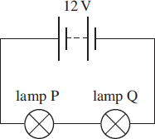

(i)      Explain why the lamps will not be at their normal brightness in this circuit.

______________________________________________________________

______________________________________________________________

______________________________________________________________

______________________________________________________________

______________________________________________________________

**(2)**

(ii)     State and explain which of the lamps will be brighter assuming that the resistance of the lamps does not change significantly with temperature.

______________________________________________________________

______________________________________________________________

______________________________________________________________

______________________________________________________________

**(3)**

**(Total 12 marks)**

**Q12.** (a)    The cell in **Figure 1** has an emf of 3.0 V and negligible internal resistance.

**Figure 1**

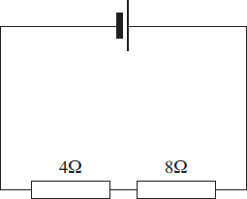

Calculate the potential difference across the 8 Ω resistor.

potential difference ____________________ V **(2)**

(b)     **Figure 2** shows the same circuit with a voltmeter connected across the 8 Ω resistor.

**Figure 2**

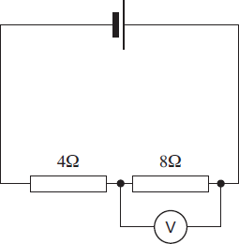

The voltmeter reads 1.8 V. Calculate the resistance of the voltmeter.

resistance ____________________Ω **(3)**

**(Total 5 marks)**

**Q13.**

Three identical resistors **X**, **Y** and **Z** are connected across a battery as shown.

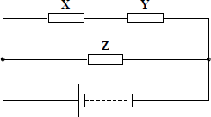

The ratio   is

|  |  |
| --- | --- |
| **A** |  |
| **B** |  |
| **C** | 1 |
| **D** | 2 |

**(Total 1 mark)**

**Q14.**

The diagram shows a network of four 2 Ω resistors.

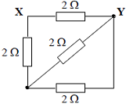

The effective resistance, in Ω, between **X** and **Y** is

**A**       0.5

**B**       1.2

**C**       1.7

**D**       2.0

**(Total 1 mark)**

**AQA Electricity Booklet 1** Mark schemes

**Q1.**

B

**[1]**

**Q2.**

(a)     (i)      *I* =  = 0.80 A **(1)**

(ii)     *P* = (0.80)2 × 5 = 3.2 W **(1)** (allow e.c.f. from (a)(i))

**(2)**

(b)     *I*tot =  **(1)** = 1.60 (A) **(1)**

*I* =  = 0.80 (A) **(1)** (allow e.c.f. from *I*tot)

**(3)**

(c)     same brightness **(1)**   
because same current **(1)**   
[or an answer consistent with their current values]

**(2)**

**[7]**

**Q3.**

(a)     (i)      three resistors in series **(1)**

(ii)     *R* = 3.0 + 4.0 + 6.0 = 13 Ω **(1)**

(iii)     three resistors in parallel **(1)**

(iv)     **(1)**

*R* = 1.3 Ω **(1)**

**5**

(b)     (i)      two resistors in parallel give  and *R’* = 2.0 (Ω) **(1)**

total resistance = (2 + 4) = 6.0 Ω **(1)**

**4**

(ii)     divide the emf in the ratio of 2 : 4 **(1)**to give 4.0 V **(1)**[or any suitable method]

**[9]**

**Q4.** D

**[1]**

**Q5.**

(a)     (i)      no of bulbs =  = 46 **(1)**

(ii)     (use of *P* = *VI* gives) *I* =  = 0.080 A **(1)**

(iii)     resistance of each bulb =  = 63 Ω (62.5 Ω)

(allow C.E. for number of bulbs and value of *I*)

[or *R*  = 62.5 Ω or  = 62.5 Ω]

**5**

(iv)    energy consumed by the set = 0.4 × 46 × (2 × 60 × 60) **(1)**= 132 kJ **(1)**(allow C.E. for number of bulbs from (i))

(b)     (i)      no of bulbs = 56, gives total resistance = 62.5 × 56 (Ω) (= 3500) **(1)**

*I* =  = 0.066 A **(1)** (0.0657 A)

(use of 63 Ω gives 0.065 A)

(allow C.E. for no. of bulbs in (a) (i) and *R* in (a) (iii))

(ii)     bulbs would shine less bright **(1)**

**3**

**[8]**

**Q6.** C

**[1]**

**Q7.** (a)     (i)      *P* = *V*2/*R* with substitution: 144/any resistance

C1

37.9 (W)

A1

**2**

(ii)     use of 1/*R* formula with substitution of some data  
even if not all five resistors

C1

correct calculation of 1/*R* (giving 0.897)

C1

1.11 (Ω)

A1

**3**

(iii)     144/their aii

C1

129 to 131 (W) **ecf**

A1

**2**

(b)     lower resistance needed

B1

(to achieve) higher current (for *l* 2*R* to be the same)/ correct use of *V*2/*R*

B1

**2**

**[9]**

**Q8.**

(a)     (i)      *(use of V=Ir)* V= 4.2 × 1.5  = 6.3 (V)

**1**

(ii)     pd = 12 − 6.3 = 5.7 V  *NO CE from (i)*

**1**

(iii)    (*use of I = V / R*) *I* = 5.7 / 2.0 = 2.8(5) A

*CE from (ii) (a(ii)/2.0) accept 2.8 or 2.9*

**1**

(iv)    *I* = 4.2 – 2.85 = 1.3(5) A 

*CE from (iii) (4.2 −(a)(iii)) accept 1.3 or 1.4*

**1**

(v)     *R*= 5.7 / 1.35 =4.2 Ω 

*CE from (iv) (a(ii) / (a)(iv)) Accept range 4.4 to 4.1*

**1**

(vi)     

*CE from (a)(v)*

*Rparallel* = 1.35 **Ω**

*second mark for adding internal resistance*

*Rtotal* = 1.35 + 1.5 = 2.85 Ω  
OR  
R = 12/4.2   
R= 2.85 Ω 

**2**

(b)    (i)

|  |  |
| --- | --- |
| resistor | Rate of energy dissipation (W) |
| 1.5 Ω internal resistance | 4.2 2 × 1.5 = 26.5 |
| 2.0 Ω | 2.85 2 × 2.0 = 16.2 (15.68 − 16.82) |
| R | 1.352 × 4.2 = 7.7 (7.1 − 8.2) |

*CE from answers in (a) but not for first value*

*2.0: a(iii)2×2*

*R: a(iv)2×a(v)*

**3**

(ii)     energy provided by cell per second = 12 × 4.2 = 50.4 (W)   
energy dissipated in resistors per second = 26.5 + 16.2 + 7.7 = 50.4   
(hence energy input per second equals energy output)

*if not equal can score second mark if an appropriate comment*

**2**

**[12]**

**Q9.**

(a)     (i)      voltage = 0.01 × 540 = 5.4 V **(1)**

**1**

(ii)     voltage = 15 – 5.4 = 9.6 V **(1)**

**1**

(iii)     (use of resistance = voltage/current)

resistance = 9.6/0.01 **(1)** = 960 Ω **(1)**

**or** *R*T = 15/0.01 = 1500 Ω **(1)**

R = 150 – 590 = 960 Ω **(1)**

**or** potential divider ratio **(1)(1)**

**2**

(iv)    (use of 1/R = 1/R1 + 1/R2)

1/960 = 1/200 + 1/R2 **(1)**

1/R2 = 1/960 – 1/1200

R2 = 4800 Ω **(1)**

**2**

(b)     (voltage of supply constant)

(circuit resistance decreases)

(supply) current increases or potential divider argument **(1)**

hence pd across 540 Ω resistor increases **(1)**

hence pd across 1200 Ω decreases **(1)**

**or** resistance in parallel combination decreases **(1)**

pd across parallel resistors decreases **(1)**

pd across 1200 Ω decreases **(1)**

**3**

**[9]**

**Q10.**

(a)     (i)      **1/R total = 1/(40)**+1/(10+5)  = 0.09167 R total = 10.9 kΩ 

**3**

(ii)     I = 12 / 10.9 k = 1.1 mA

**1**

(b)

|  |  |
| --- | --- |
| position | pd / V |
| AC | 6.0 |
| DF | 4.0 |
| CD | 2.0 |

*C.E. for CD*

**3**

(c)     (i)      AC: no change  
constant pd across resistors / parallel branches(AE) 

*no CE from first mark*

**2**

(ii)     DF: decreases  
as greater proportion of voltage across fixed / 10 k Ω resistor 

*no CE from first mark*

**2**

**[11]**

**Q11.**

(a)      (i)     *(use of P=VI)*

I = 36/12 + 6/12  = 3.5 (A) 

**2**

(ii)     *(use of V=IR)*

R = 12/3 = 4 (Ω) 

**1**

(iii)     *R* = 12/0.50 = 24(Ω)

**1**

(b)     terminal pd/voltage across lamp is now less OR current is less 

due to lost volts across internal resistance OR due to higher resistance 

lamps less bright 

**3**

(c)     (i)      current through lamps is reduced as resistance is increased **or**pd across lamps is reduced as voltage is shared 

hence power is less OR lamps dimmer 

**2**

(ii)     lamp Q is brighter 

lamp Q has the higher resistance hence pd/voltage across is greater 

current is the same for both 

hence power of Q greater 

**3**

**[12]**

**Q12.** (a)    potential divider formula used or current found to be 0.25 A **C1**

2.0 V *allow 1 s.f.* **A1**

*1.0 V (with working) gains 1 mark*

**2**

(b)     main current =1.2 V / 4 Ω = 0.3 (A) **C1**

Rtotal = 1.8 V / 0.3 A = 6 Ω or *I*8 = 0.225 (A) **C1**

RV = 24 Ω **A1**

**3**

**[5]**

**Q13.**

A

**[1]**

**Q14.**

B

**[1]**